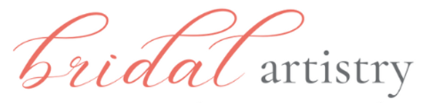 On-site Makeup

2025 Contract of Agreement / with Trial

This contract stipulates that Bridal Artistry will provide on-site makeup services for the

wedding of _________________________________ on __________________.
(bride) (wedding date)

Makeup Artist will arrive at _____________ at the following location:
(time)
Getting ready address___________________________________________________

Contact phone for wedding day __________________________________

Bride needs to be ready by _________________________ (finish time for makeup)

I understand the fee for the bride’s makeup will be a total of $290, which includes the pre-wedding trial and a full-size lip color or gloss + false lashes, if desired.

For an additional fee of $120 each, Bridal Artistry will provide makeup services, including a full-size lip color/gloss to keep + false lashes (if wanted)for the following members of the party*:

___________________________________________________________________
*Numbers are locked in 1 month before the wedding & cannot be reduced (add-ons may be possible)

If travel outside of Wilmington is required, a travel fee will apply. Any necessary parking fee will be paid also by the bride.

A $290 non-refundable deposit by cash or check will be required to reserve services for the wedding date. Balance is due on the day of the wedding (cash or Venmo preferred).

I agree to the terms of the contract ________________________________ Date ______________
(Bride’s Signature)

Email _____________________________________________ Cell # ____________________________

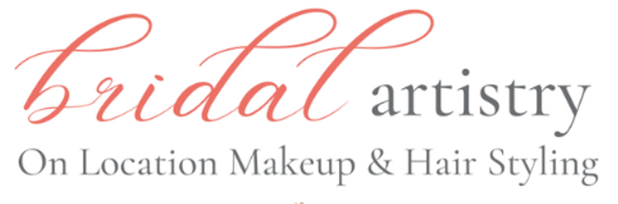

Bridal.Artistry@gmail.com Deposit paid $__________________________
www.bridalartistryNC.com
703-380-9961- cell Balance due $___________________________

Photo Release

_____ Yes, bride ______________________________ has no problem with the use of professional photo images from her wedding used for advertising by Bridal Artistry. Photos may be posted on Bridal Artistry websites and on our social media to promote our makeup & hairstyling services.

_______ No, bride requests no photo images from the wedding to be shared by Bridal Artistry.

Allergy Release

________This advises my Bridal Artistry makeup artist that _____________________________________
has an allergy or sensitivity to the possible makeup product ingredients listed below and I will not hold Bridal Artistry responsible to any possible reaction to sensitivities beyond those listed here:

________ There are no known allergies for bride or bridal party.

Timing Parameters

_______ I understand that the agreed upon finish time on this contract will be firm within one-hour either way. However, if it is necessary to move the timeline due to unforeseen circumstances, I understand that Bridal Artistry may need to make changes and I will discuss this as soon as I am aware with Barbara Hill,
owner of Bridal Artistry.

***************************************************************************************************************************
Flawless powder compact for touch ups

________ Yes, I would like to get a FLAWLESS POWDER COMPACT matched to my skin tone to keep on the wedding day for any touch ups. $59 additional charge will be added to my balance due on the wedding day.
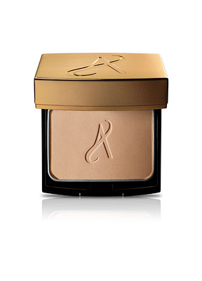
Signed________________________________________________ Date _______________________

