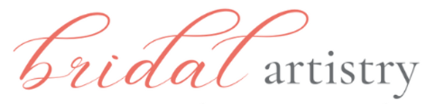2025 On-site
MAKEUP & HAIR

Contract of Agreement with Trial

This contract stipulates that Bridal Artistry will provide on-site makeup & hair services for the

wedding of _________________________________ on ________________.
(bride) (wedding date)

Makeup Artist will arrive at ________ & Hair Stylist at _________ at the following location:
(time) (time)
Building & Address___________________________________________________

Contact phone for wedding day __________________________________

Bride/others need to finish makeup & hair styling by _________________________ (time)

I understand the fee for the bride will be $510, which includes the makeup & hair trial session, a full size lip color or gloss to keep + false lashes, if desired.

For an additional fee of $120 each we will provide makeup for #_______ * members of the wedding party. Each gets a lip color to keep & false lashes, if wanted. Also, #________* members will have their hair styled for $110 each. Fee for flower girls (aged 7 & under) hairstyling is $50. Hairstylist may add a surcharge for unusually long/thick hair or intricate hairstyling requested. $20 surcharge for clip-in hair extensions added to styling of wedding party.

* Numbers are locked in 1 month before the wedding & cannot be reduced (add-ons may be possible)

Travel outside Wilmington, NC, will require a travel fee. Any parking fees necessary for on location work will be reimbursed by the bride.

A $510 non-refundable deposit by Venmo or check will be required when the contract is signed. Balance for others will be due on the wedding day ~ cash or Venmo .

I agree to the terms of the contract ________________________________ Date ______________
(Bride’s Signature)

Email ____________________________________ Cell # _________________________________

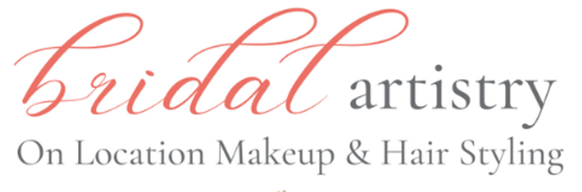
Deposit paid $__________________________
www.bridalartistryNC.com
bridal.artistry@gmail.com
703-380-9961- cell Due on wedding day $____________________

Photo Release

_____ Yes, bride ______________________________ has no problem with the use of professional photo images from her wedding used for advertising by Bridal Artistry. Photos may be posted on Bridal Artistry social media sites to promote our makeup & hairstyling services.

_______ No, bride requests no photo images from the wedding to be shared by Bridal Artistry.

Allergy Release

________Yes, this advises my Bridal Artistry stylist/artist that __________________________________
has an allergy or sensitivity to the possible product ingredients listed below and I will not hold Bridal Artistry responsible to any possible reaction to sensitivities beyond those listed here:

________ There are no known allergies for bride or bridal party.

Timing Parameters

_______ I understand that the agreed upon finish time on this contract will be firm within one-hour either way. However, if it is necessary to move the timeline due to unforeseen circumstances, I understand that Bridal Artistry may need to make changes and I will discuss this as soon as I am aware with Barbara Hill,
owner of Bridal Artistry.

__________ Yes, I would like to get a FLAWLESS POWDER COMPACT matched to my skin tone on my wedding day to keep for any touch ups. $59 will be added to my balance due on the wedding day.
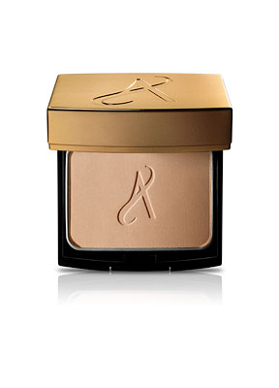

Signed________________________________________________ Date _____________________

